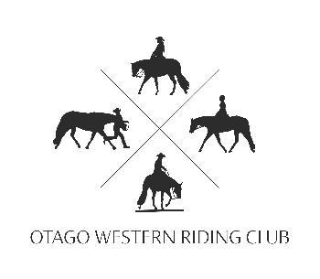
OTAGO WESTERN RIDING CLUB
CLUB RULES FOR USE OF INDOOR ARENA AT TELFORD
UPDATED May 2025

- Telford is a working farm; and has enforced a NO DOGS Policy, so please leave your beloved pets at home.
- Please ensure you tidy up any hay and horse droppings around you float/truck and any yards, stables or taped of section of paddock that you have used. THIS INCLUDES THE CARPARK!!
- Midway gate down main driveway MUST be closed at all times.
- Spectators must not accumulate in horse arena. This area is for horse handlers/riders only. No deck chairs, no prams. Please use alternative entrance as indicated beside the toilet entrance door.
- All members must have their membership paid up prior to 31st July each year to be eligible for Club end of season trophies.

- Only horses and riders officially entered on the day, in the Club Shows/events/training may ride or be penned/stabled at the Telford Equestrian Unit. However, application can be made to the organiser or organising committee, for request of a non- included horse to be present on the grounds and use the facilities. All relevant fees must be paid ( ie : yard/stable fee, arena fee contributions. Please note any request made is not guaranteed approval and preference will be given to those horses involved in show/event/training at any time. If you arrive at OWRC grounds without prior authorization of non-competing animal you risk expulsion from the grounds and a fine.

- Horse floats that have horses tied to them MUST be attached to a vehicle.
- Building Emergency procedures are as per instructions in the kitchen at the covered arena.
- All other rules as per the AQHA rule book 2023. Please read this rule book annually for any updates.

Club contact is the Secretary: otagowesternridingclub@hotmail.com

